Case. Chinese geographic names
Credits 1
Here you see the Chinese geographic names and their translation to English.
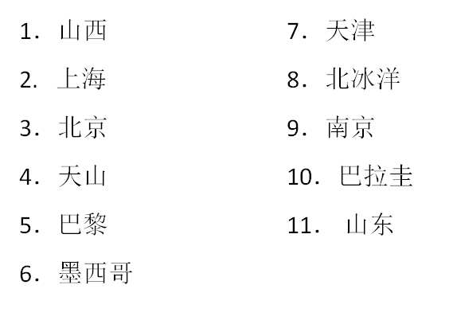
Shanxi, Paris, Nanking, Tien Shan, Paraguay, Tianjin, Beijing, Shanghai, Shandong, Mexico, Arctic Ocean.
Please, do not use Chinese-English dictionary and define the correlation between names. Explain your logic. If something is wrong, perhaps, any other language will give you a solution.

